

**ECONOMIC ANALYSIS EXPLORER**

User Guide



**IS428 Visual Analytics for Business Intelligence**

**2016-2017 Term 1**

Setup

Please use Chrome browser to view this visualization, as our positioning and functions rely on Chrome’s implementation. Running on other browsers such as Safari and Firefox would render some charts in different positions or not at all.   
  
Additionally, a local server needs to be run due to the browser’s in-built protection for cross-origin requests for some of our libraries and usage of local csv files. A server can be run in a simple manner to open index.html. The following are simple ways using either NodeJS or Python.

NodeJS:  
1. Install node.js.   
2. Open command prompt and CD (change directory) to this project folder.   
3. Run “npm install –g http-server” to install the http package, and after it is installed, enter http-server. Go to localhost:8080 in your browser, and you should see the app running.  
  
Python:  
1. Python should be available in most distributions. Open Terminal, and CD to this project folder and enter “python –m SimpleHTTPServer” for Python 2.7, or “python3 –m http.server” for Python 3.x+  
2. Go to the stated address the server is running, and you should see the app running.  
  
Additional steps can be found at : <http://stackoverflow.com/questions/18586921/how-to-launch-html-using-chrome-at-allow-file-access-from-files-mode>

Using the app

1. **Selection**

Our application offers the ability to compare economic indicators between countries or regions. You can compare up to three selections at a time, or view one only. If you fulfill the first box, one selections’ data will be shown. If you select another in a separate option, then you will be able to see it on the graph and start to compare. And so on by completing the third box.  
  
One can begin their analysis of one country, and select other countries/regions to compare against. For example, comparing how one country fares against their closest competitors. Later on, other countries can be analyzed in a similar way, to see if they are heading towards a similar growth/decline trend in terms of indicator values changing, and whether their industries follow the same pattern.

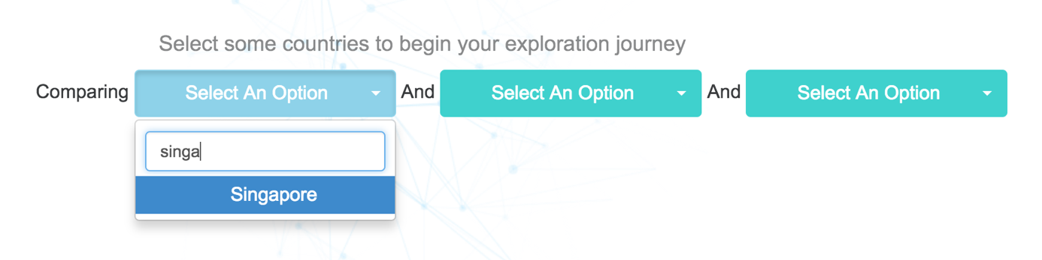You can search for a country or region by selecting one of the options and typing a query, as shown in the image above  
Once an option has been selected, you will see two type of charts being rendered:

1. *Glyph Chart*

The glyph or radar chart is formed with a colored circle for each of the indicators. The indicators are the rates of Inflation, Unemployment, GDP growth, Central Government Debt, Lending Interest Rate and Deposit Interest Rates (aka savings rate). We can see that Singapore has a very high Central Government Debt rate, due to using CPF as a form of debt to fund government initiatives (askST, 2016).

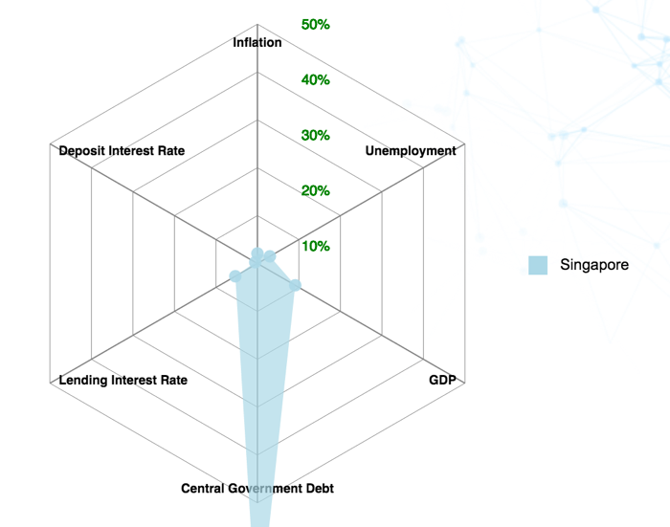  
The circles are placed at locations relative to the rings, which increments in steps of 10% as you it goes outwards. A colored area is formed, connecting the circles together in a configuration that allows you to see comparisons with other selections on the same chart.  
  
The colors represent your selection, which appears a colored legend to let you know which colored areas represent your selections when you select more than 1 option.

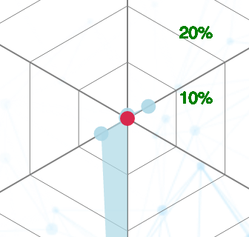

When a point on the glyph chart is red, it means that the value of the indicator has changed to negative, implying negative change/contraction of its respective indicators such as GDP.

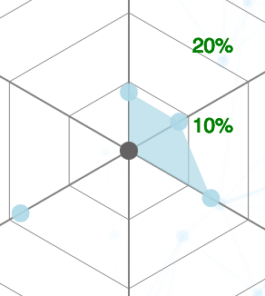

A gray colored circle means that a data point is blank or a NaN value. This means that data could not be obtained by our sources.

1. *Stacked Area Chart*

This chart plots the overarching sectors contributing to GDP of a country. The x axis represents the year, and y axis for cumulative percentage of GDP. Note that some countries or regions do not have a sector contributing to their GDP.

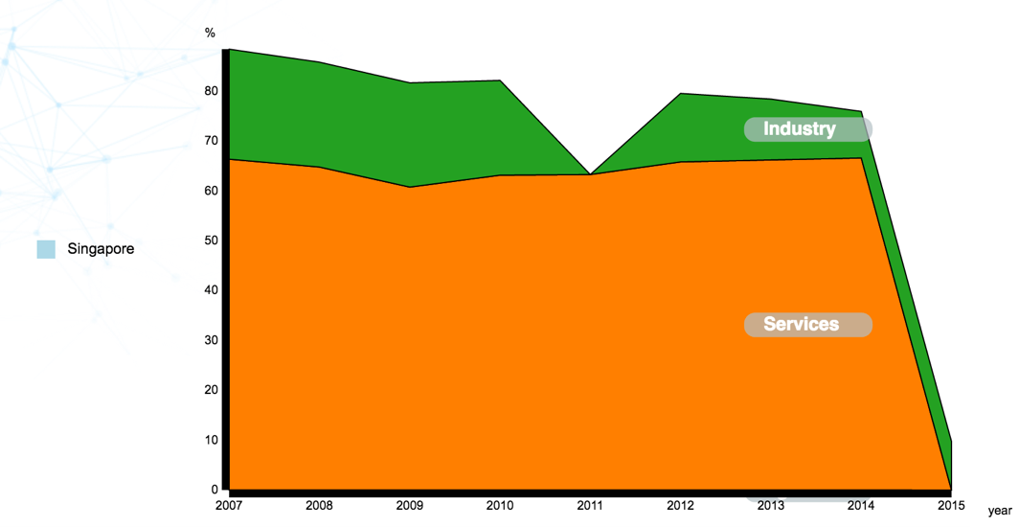

The legend appears next to its corresponding stacked area chart, representing your selection. Each color is representing a sector, either Agriculture, Industry or Services.

1. **Analyze Changes Over Time**

Economic data is more useful to users if they can compare snapshots in one period compared to another. This change can be visualized using an animated radar chart. You can see that a timeline and play button appears the moment you make a selection.

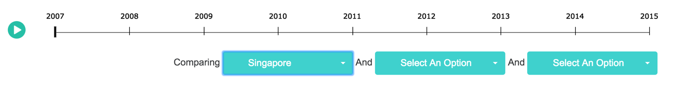

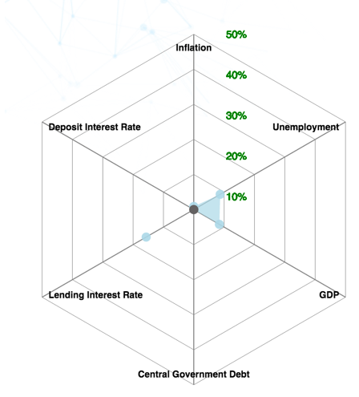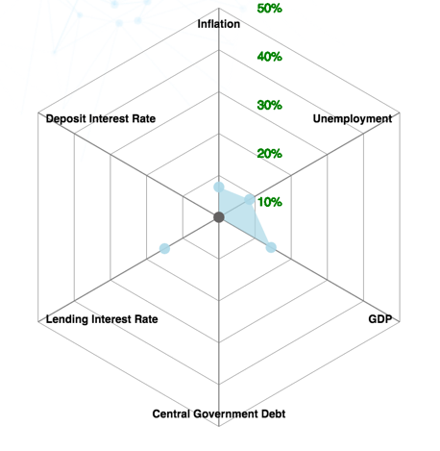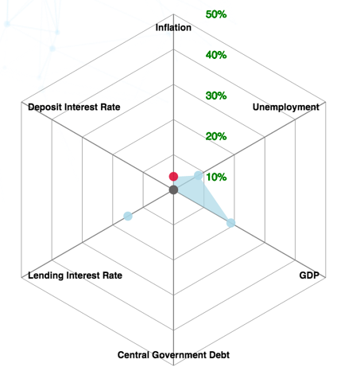Clicking on the ‘play’ button on the top left, you can begin to see the radar charts’ circles and area moving accordance to the country or region’s data in that year. Additionally, the year in focus appears on the top left. You can click ‘pause’ at any time to analyze further.   
  
  
Each year represents a ‘snapshot’ of the economic profile of the countries or regions, allowing you to see the changes over time. By doing so, one can see the evolution of these economic indicators over time and compare them to how the industries fared, revealing some insights on how well or bad the performance is, and in which particular sector.   
  
  
  
 *Timestep 1* *Timestep 2* *Timestep 3*  
  
Combined with the circle colors and radar areas changing over time, this allows you to tell a story on what may have happened in that year, such as what may have resulting in the country’s performance, or its economic policies affecting itself or other countries based on past news.

1. **Hover Tooltips**

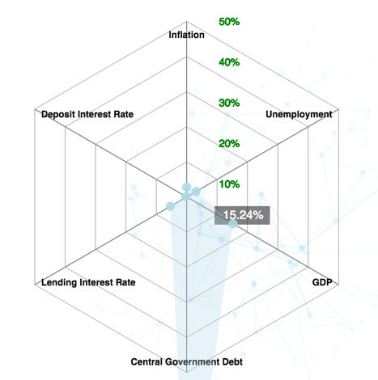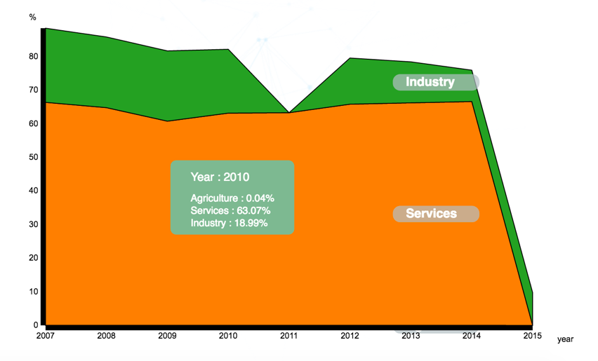You can find out the exact values of the indicators can be done by hovering over a circle in the radar chart, or over the stacked area chart in one of the time periods.

For example, we can see that GDP in 2009 was 15.24%, and what contributed to that was 63%   
from Services, and 18% in Industry. The total of industry sector contributions to GDP to not add up to 100%, as according to the World Bank, surveys are infrequent in developing countries, and industrial production for example, are not captured in formal sectors. There are some unreported, illegal or small-scale activities which are not accounted for. Thus, the figures provided should be taken as an estimate and not as exact figures when making a comparison (World Bank, 2016).  
  
We can know that in 2009, a large proportion of GDP growth in Singapore came from Services. However in 2011, we see a sharp drop in Industry, and a decline in GDP growth rate, indicating something has happened in the Industrial Sector of Singapore that weakened their economic growth. This can be attributed to the financial crises, resulting in one of the poorest performances for all countries.

Interpreting The Indicators

All the information on both charts provide a wide range of users to easily make decisions and interpret in various ways. A variety of questions could be answered according to the application, such as buying power of the currency, or if the country is a relatively good place to make investments in. Comparison questions like “Which country has the lowest inflation rates” or “Which country has a higher bank lending rate, and its change from last year?”. Users could make decisions, like moving to another country, change currencies, or find an ideal location to invest in a business using this visualization.

For users unfamiliar with the indicators used, this section serves to provide a basic understanding of how they can be interpreted when using our visualization, taken from excerpts in Investopedia (2016) and summarized using our own personal learning and experiences so far – thus please take them with a pinch of salt as they may not capture the full context of the economic effects, but general relationships between them.

Depending on your profile and purpose of usage, these indicators can serve as additional considerations – where for example, a potential job-seeker would be looking for indicators going in an opposite direction from a business owner or investor. Should you be well-versed in the indicators and its more advanced relationships, you are welcome to skip this section.  
 **Inflation:** Thisis the rateat which prices are rising in the country or region. This also means that the local currency’s purchasing power would decrease if inflation rates are high. For example, if inflation rate is at 2%, prices would increase by the same amount, reducing the buying power of the currency. In order for an economy to be smooth, a right balance of inflation should be achieved. Too high, and the currency would seem worthless and everyday items become unaffordable overnight. Too low (i.e. negative inflation), the opposite effect happens. Prices fall, and the purchasing power of the currency increases. This may be good for the buyer, but the businesses may suffer as a result. Deflation. should not be confused with disinflation, which is just a lowered/slower inflation rate.  
**Unemployment:** The proportion of total labor force out of work, but (hopefully) seeking employment and are willing to work. Ideally, this should be low, with countries making an effort to keep levels low, resulting in a near-full employment capacity and thus productivity and GDP growth of the country. A high unemployment rate is sound warning on the health of a country, indicating a loss of job security due to policies passed, or a country undergoing mass layoffs in a recession. Common forms of unemployment are frictional and cyclical, the former being the lag required before getting a job, and the latter due to supply-demand mismatch.  
  
The unemployment rates matter in overall, as high rates indicate that families would lose wages earned, and the country as a whole suffers due to its decline in contribution to the economy due to less goods and services being produced. Thus, this indicator can be tied closely with GDP.  
  
**GDP:** The monetary value of goods and services produced by a country in a time period. Negative GDP rates are clear indication that the economy is in contraction, as they are not able to keep up their pace of growth. This may or may not imply a recession.  
  
**Central Government Debt:** Also known as Sovereign Debt, it is issued to finance the country’s growth and development. In the case for Singapore, we have relatively high levels due to the Sovereign Debt being funded primarily by CPF (retirement) accounts of all Singaporeans & PRs. Therefore, some levels may be significantly higher due to the approach the government’s economic policies which affect how this debt is funded. Debt can be repaid by the government raising taxes, reducing spending, or printing more money. Each of these actions have consequences on the economy the country, region and potentially globally.   
**Lending Interest Rate:** This represents the interest charged by banks on their loans. If interest rates are high, businesses would have higher costs to operate on loans and stocks would be unfavorable to invest as a result. This may also have a lagged inflationary effect due to expensive and thus slower money lending. If interest rates are low, this means lowered costs to operate businesses, resulting in favorable time to invest in stocks. This has a lagged deflationary effect to money being lent cheaply and quickly.  
  
**Deposit Interest Rate:** This represents the savings interest rate of banks, primarily affecting citizens who keep their money in the bank. A high rate implies an increased incentive for citizens to save, but possibly higher taxes. This also reduces the price of bonds, meaning stocks are more favorable to invest in. A low rate implies decreased incentive to keep the money in the bank, and bonds would be more favorable to invest in.

Thank you

We hope you enjoy using our application, and that it will help you to discover and interpret economic phenomena in a simpler way.

#### **References**

#### askST: Why does Singapore have an external debt of US$1.766 trillion?. (2016). The Straits Times. Retrieved 18 November 2016, from <http://www.straitstimes.com/business/askst-why-does-singapore-have-an-external-debt-of-us1766-trillion?utm_campaign=Echobox&utm_medium=Social&utm_source=Facebook&xtor=CS1-10#link_time=1479686536>

#### Industry, value added (% of GDP) | World Bank (2016). Data.worldbank.org. Retrieved 18 November 2016, from <http://data.worldbank.org/indicator/NV.IND.TOTL.ZS>

#### Investopedia - Sharper Insight. Smarter Investing.. (2016). Investopedia. Retrieved 19 November 2016, from <http://www.investopedia.com/>